MECHANICAL ENGINEERING SEMINAR
Monday, May 8th, 2023 at 14:30, D. Dan and Betty Kahn Building, Auditorium 1

Nano Foam Resonators
Assaf Ya’akobovitz, Ph.D.
Professor of Mechanical Engineering
Ben-Gurion University
Email: assafyaa@bgu.ac.il;
Website: https://assafyaa.wixsite.com/nems-mems-lab-bgu
Hosted by: Prof. Dan Mordehai

Two-dimensional materials hold a promising potential to be integrated into engineering systems due to their outstanding physical properties, such as high mechanical strength, thermal stability, and semiconducting behavior. Recent Progress in synthesis methods allowed the realization of two-dimensional materials in the form of a three-dimensional network, also known as nano foam. In my lecture, we will focus on graphene foam (GF) and hexagonal boron-nitride (BN) resonators.
We developed a process to build suspended GF electrostatic actuators and we investigated their dynamics and how the electrostatic pressure changes their morphology. In addition, we developed BN resonators. Since BN is a large bandgap semiconductor, we developed a new approach for exciting them using Kelvin polarization force.
Both GF and BN showed significant dissipation as the quality factor values that we measured, even under high vacuum conditions, were low (below 100). These observations inspired us to study the dissipation mechanisms underlying the dynamics of layered foam materials that showed that atomic friction between the layers is the most dominant dissipation source.
We finalize our talk with an applicative example, as we developed GF resonative COVID-19 sensors. We developed a protocol to allow the exposure of the sensors to liquid and our experimental analysis showed that our sensors exhibited very high sensitivity, as their limit of detection is as low as ~5000 viruses.

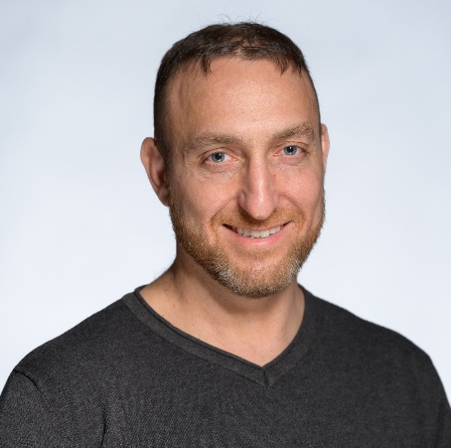
Assaf Ya’akobovitz graduated his bachelor's and master’s degrees (both magna cum laude) in the direct program for outstanding students in Mechanical Engineering at Tel-Aviv University. Then he pursued his Ph.D. degree, during which his research focused on carbon nanotubes and MEMS devices. He completed his first post-doctoral fellowship at the University of Michigan at Ann Arbor and an additional post-doctoral fellowship at the Weizmann Institute of Science. Currently, he is the head of the NEMS/MEMS and Nano-Materials Laboratory at Ben-Gurion University.

